**IFT 266 Introduction to Network Information Communication Technology (ICT)   
  
Lab 38**

**IPv6 DHCP through VLAN Setup and Configuration**

Co-authored by Matthew Buchan

**After you complete each step, put a ‘√’ or ‘x’ in the completed box**

1. Set up the following topology in packet tracer.

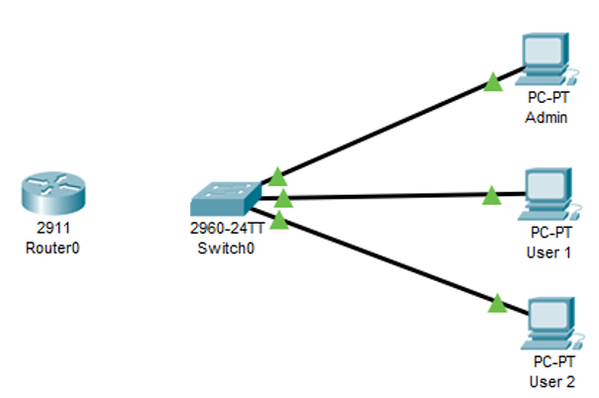

Admin PC will be in VLAN 10 and the users will be in VLAN 20.

Switch and router will need to be configured before being connected

Admin PC connects to switch port Fa0/1 via straight through cable

User PCs connect to switch port Fa0/13 and Fa0/14 via straight through cable



1. We will now setup the VLANs on the switch with the following command.

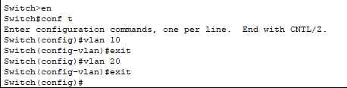



1. Now let’s look at the VLANS that you just setup by using ‘show vlan’ command

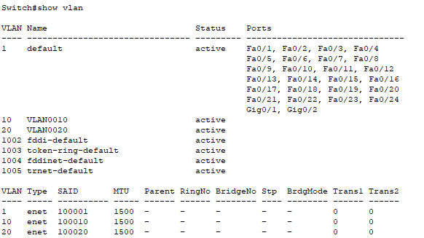



1. We will now configure the switch so that Port (interface) 1 will be configured to use VLAN 10. A specific port range (13 – 24) will be assigned for VLAN 20. Time can be saved if the range command is used to configure multiple ports.

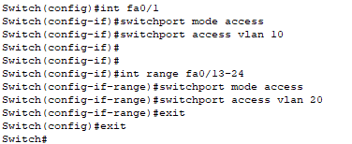

1. Now we will check to see if the ports have been properly configured by using the ‘show vlan’ command.

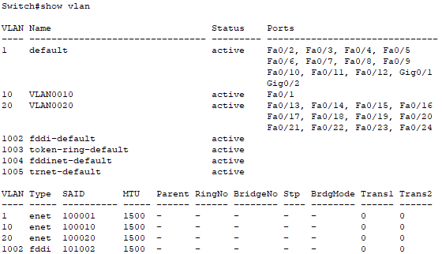



1. Next we will need to configure a port for trunking. Two gigabit Ethernet connections exist on the switch that are not being utilized for host systems. gigabitEthernet 0/1 will be the port we utilize for trunking.

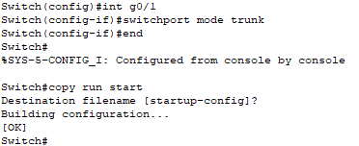



1. Now that the switch has been configured, you will need to configure the router. The IPv6 prefix we will be using is 2001:db8:abcd:2140::  
     
   Run the following commands to commands to enable unicast routing and configure the admin dhcp pool:

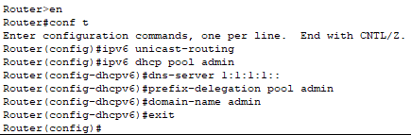

Repeat the process (except enabling unicast-routing) to create a ‘user’ dhcp pool.



1. Once the pools have been created, they must be assigned addresses. In this case, we will be assigning each pool to separate subnets (2140/2141). Run the following commands to assign addresses to the IPv6 pools.

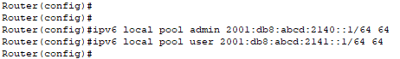



1. Now that the pools and addresses are established, the interface must be configured. Each interface can be split into sub interfaces to support different VLANS. Use the following commands to configure the VLAN 10 sub interface:

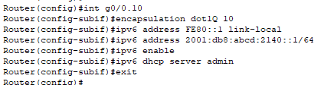

Repeat the same steps for VLAN 20 using the user dhcp server



1. You’ll notice that the connections remain red when the router (port g0/0) and switch (port g0/1) are connected. This is because the router port needs to be enabled. Once enabled, you should also see the sub interfaces change state to up.

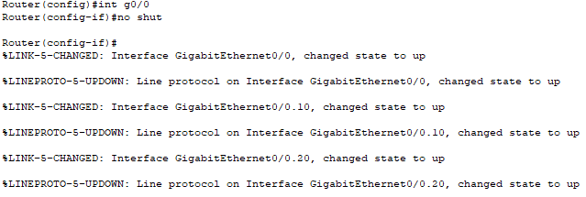



1. 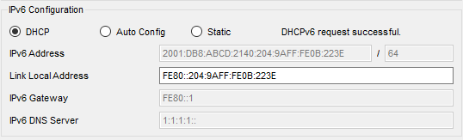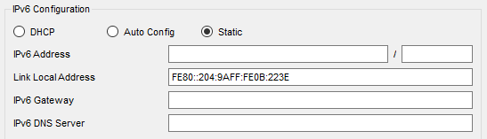You should now be able to obtain a DHCP address on each PC and be able to ping.

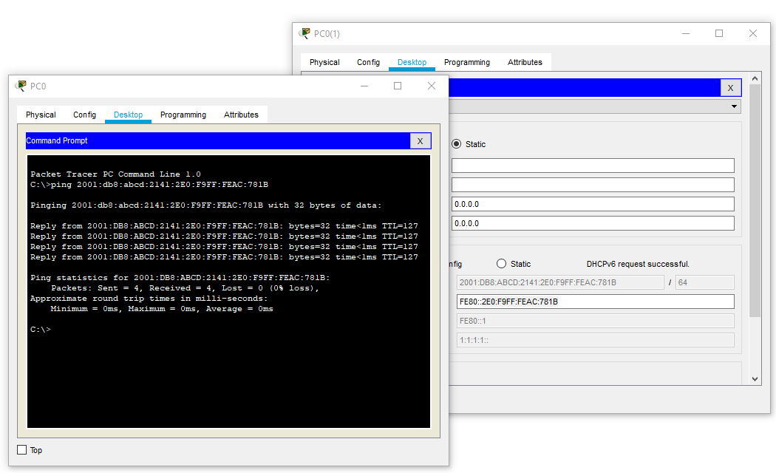



1. If future network devices need to be added to the user network, they simply need to be connected to an open port in the assigned range. Once connected, they will obtain the same VLAN connection as the other user computers.

